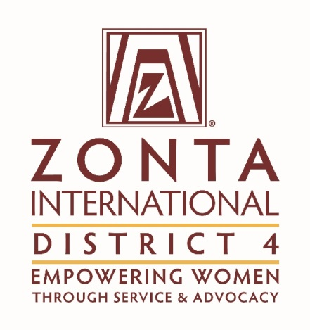

November 19, 2016

Hauptman Woodward Institute,
700 Ellicott St,
Buffalo, NY 14203, USA

9:30 am to 4:00 pm
Meeting Chair: Governor Lori Robinson
 |  | Report  Attached or D4 Website | Presenter /Motion required | Time
1 | Call to order - Welcome |  | Governor Lori Robinson | 9:30
2 | Declaration of Conflict of interest |  | Governor Lori Robinson | 9:31
 | Review of the Agenda  Consent Agenda | Reports on D4  Website | Any additions or deletions (approval of the agenda is not required unless there are changes to the agenda)  Reports submitted and posted on the website  Amelia Earhart  Ambassador’s  Archives Historian  Awards  Bylaws  Centennial Committee  Communications  Membership Report  Risk Management  Service  SOM  United Nations  Z and Golden Z Club Report | 9:32
 | Approval of the Minutes from Sat. May 14^{th,} 2016 |  | Additions Discussion  Motion: That the minutes of the meeting dated Saturday May 14th be approved. | 9:35
 | Governor’s Report | Post on screen report | Lori Robinson  Committee highlights  Ambassador’s $850 from Stella retreat  Every Member Every November  16 Days of Activism Challenge  United Nations Gov. Lori to request AD’s for action on behalf of the committee | 9:40
 | Treasurer’s Report  Risk Management | D4  Website  Emailed sheet to Area Directors | Roxy Rapedius  That the Treasurer’s report dated August 31st be received for information  Information regarding board insurance  Board Insurance | 10:15
 | UN visit |  | Gov. Lori Robinson | 10:30
 | Membership |  | Gov. Lori to discuss the info from ZI  Lt. Gov. | 10:40
 | Centennial Committee |  | Lt. Gov. Bonnie | 10:50
 | Reports not Posted on the Web Site Prior to Agenda circulated |  | Advocacy  Leadership  Nominating  Conference 2017 | 11:00
 |  |  | Reporting form Lori | 11:10
 | Area Director Updates |  | Gov. Lori Report form discussion | 11:15
 |  |  | Area 1 Director Sheena Poole Report | 11:20
 |  |  | Area 2 Director Clair Wallace | 11:25
 |  |  | Area 3 Director Karen Fritsch | 11:30
 |  |  | Area 4 Director Kathi Scanlon | 11:35
 |  |  | Area 5 Director Janice Durmis Report | 11:40
 |  |  | Area 6 Director Beth Zak | 11:45
 |  |  | Wrap up discussion
 | Lunch |  |  | 12:00
 | Committee and Board Goals | To be projected | Gov. Lori | 12:45
 | ZI web site and new PP’s  Training |  | Gov. Lori | 1:30
 | AD’s You are invited to speak |  | Gov. Lori New Power Point | 2:00
 | Area Workshops 2017 |  | Info for the committee | 2:15
 | New Business |  |  | 2:45
 | Events | Candle PP  Info sheets | - Niagara Falls Ontario Nov. 24th  - Buffalo walk on Dec 1st  Make sure we are encouraging clubs to send info for the website calendar | 3:00
 | Motion to Adjourn |  |  | 3:15

Next Meeting: Elected Board and all committee Chairs meeting Saturday, January 7th, 2016 9:00 am to 11 am Go To Meeting

All reports to be sent to Sandra for the web site by December 23rd 2016
on: www.zondistrict4.org

Notes: ________________________________________________________________________________________________________________________________________________________________________________________________________________________________________________________________________________________________________________________________________________________________________________________________________________________________________________________________________________________________

