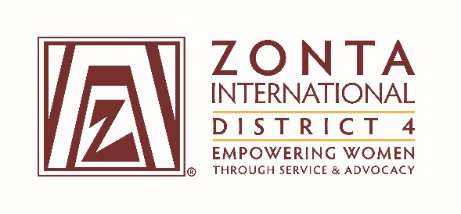
COMMITTEE CHAIR REPORT TO BOARD

DATE: January 2016 COMMITTEE Advocacy _

HIGHLIGHTS:

Since the last Advocacy Committee report Zontians in D4 have been very busy. Clubs are progressing with the District Poster Project and we look forward to hearing about their findings when they have some measurement of the impact of the Project in their areas. I worked with a club member to help their club get started and they are quite excited about the Project.

In November the actions taken during the ’16 Days’ took many forms: film, videos on YouTube, speakers, working with like-minded organizations and having Niagara Falls bathed in orange.

Doreen Myers led a delegation of D4 members to the UN in December. Their Briefing focused on Counter-Terrorism and Education for Women. Information is already being distributed in regards to CSW 60 which will be held over a 2-week period at the UN in mid-March and Zontians who wish to attend can do so.

I am continuing to do monthly ‘infomercials’ and the clubs are appreciative. I also monitor various news feeds for articles regarding women’s issues.

Pittsburgh has been active in working with Cities for CEDAW, and we are being included in presenting to, and facilitating, a group discussion at the UN Commission on the Status of Women in March in New York. Other D4 members are encouraged to attend.

We are looking at 2 interesting kits: Women Preventing Violent Extremism – An Action Kit and Women Preventing Violent Extremism – A Thought For Action Kit.

CHALLENGES:
Getting information from clubs about their activities.

Respectfully submitted:

Lee Fogarty/Connie Deckert

