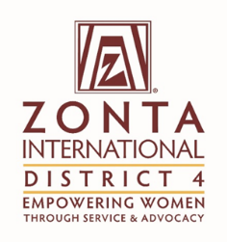 | Title: | Foundation Ambassador’s Report
 | From: | Ann Marie West and Kathy Smith
 | Date: | April 30, 2017

To: | The Zonta International District 4 Board

Purpose of the report (please mark as many as applicable):

x | For Information |  | For Discussion |  | For decision

Facts (Information)
This section can contain activities since the last report, factual information to be brought to the Board regarding issues from Clubs or from Committees, other matters.

If the report is a follow-up to a previous report, refer to the date, title, and decisions of the previous report.

Initiative | Specific Actions | Highlights/Challenges
Attended all three area workshops | Presented a brief history of Zonta and UNICEF and an update on the Let Us Learn Madagascar international project | Received favourable comments re: presentation.  Members appreciated hearing about the results of projects
Collected donations from members attending the workshops | Donations received were as follows:  Areas 1 & 2 - $575  Areas 3 & 4 - $1910  Areas 5 & 6 - $720 | Many members were happy to receive the lovely bracelets when they donated at least $50 to the foundation. Great idea Ann Marie!
Attended Niagara Falls, NY meeting | Made a presentation about the International Service projects | Received about $300 in donations from individuals
Attended Bradford meeting |  | Club donation received
Attended Batavia High School Z Club meeting |  | Proceeds from their 5 km run going to Let Us Learn Madagascar ( approx. $1000)
Invited to Pittsburgh club meeting | Need to set a date
Comments

Motion
This section includes the motion (s) if any for the Board to discuss and vote on.
Rationale
This section includes the rationale of the motion

Evaluation (Discussion)
As board member, and voice of Clubs and committees, express the pros and cons of the motion (s) presented.

Please be clear about:

- The challenge the proposal addresses
- Stakeholders who will benefit and how
- Added value to Zonta
Supporting Documentation
List any attachments to be considered as part of this report.

