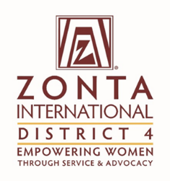 | Title: Foundation Ambassadors
 | From: | Ann Marie West and Kathy Smith
 | Date: | September 10, 2017

To: | The Zonta International District 4 Board

Purpose of the report (please mark as many as applicable):

x | For Information |  | For Discussion |  | For decision

Facts (Information)
This section can contain activities since the last report, factual information to be brought to the Board regarding issues from Clubs or from Committees, other matters.

If the report is a follow-up to a previous report, refer to the date, title, and decisions of the previous report.

Initiative | Specific Actions | Highlights/Challenges
Individuals donate to the Foundation | Incentives (bracelets) are given when donations are received | 191 out of 810 members have donated (23.6%)
All clubs within the district donate to the Foundation | Recognition to the clubs who have given | All clubs in Areas 3 and 5 have contributed
Updates on the international projects given at Fall Conference | Ambassadors attend the webinars given.  Monitor ZI website. | Powerpoint will be presented at the Conference.
Zonta says NO campaign | Highlight activities that clubs have done | Niagara Falls lighting is planned.  Encourage clubs to share their activities with other clubs.  Clubs working together on projects/activities.
Comments

Motion
This section includes the motion (s) if any for the Board to discuss and vote on.
Rationale
This section includes the rationale of the motion

Evaluation (Discussion)
As board member, and voice of Clubs and committees, express the pros and cons of the motion (s) presented.

Please be clear about:

- The challenge the proposal addresses
- Stakeholders who will benefit and how
- Added value to Zonta
Supporting Documentation
List any attachments to be considered as part of this report.

