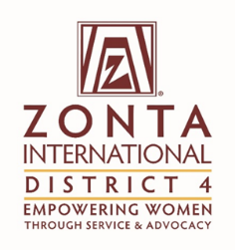 | Title: | Ambassador’s Report
 | From: | Ann Marie West and Kathy Smith
 | Date: | November 3, 2016

To: | The Zonta International District 4 Board

Purpose of the report (please mark as many as applicable):

x | For Information |  | For Discussion |  | For decision

Facts (Information)
This section can contain activities since the last report, factual information to be brought to the Board regarding issues from Clubs or from Committees, other matters.

If the report is a follow-up to a previous report, refer to the date, title, and decisions of the previous report.

Initiative | Specific Actions | Highlights/Challenges
Tips/fact sheet sent to Area Directors and Presidents | Share information with club members | Clubs are aware of the work of the Foundation this biennium.  Ambassadors are invited to club meetings to discuss the International Service Projects.
A submission has been sent to the Governor for the next newsletter. | All District 4 members are encouraged to make an individual donation. | Brampton-Caledon Zonta Club has challenged all clubs to make a donation from all members .
Ambassador presented at the Zonta Club of Kenmore. | Highlighted the service projects and the need to support the Foundation. | Many members made donations and submitted them to the Ambassador.
Every Member Every November initiative | Emphasize this initiative to all of D4 | Individuals make a donation recognizing Zonta`s birthday

Motion
This section includes the motion (s) if any for the Board to discuss and vote on.
Rationale
This section includes the rationale of the motion

Evaluation (Discussion)
As board member, and voice of Clubs and committees, express the pros and cons of the motion (s) presented.

Please be clear about:

- The challenge the proposal addresses
- Stakeholders who will benefit and how
- Added value to Zonta
Supporting Documentation
List any attachments to be considered as part of this report.

