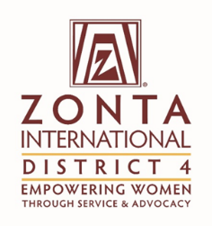 | Title: | Communications Report
 | From: | Sandra Cronk
 | Date: | Dec 23, 2016

To: | The Zonta International District 4 Board

Purpose of the report (please mark as many as applicable):

X | For Information |  | For Discussion |  | For decision

Facts (Information)
This section can contain activities since the last report, factual information to be brought to the Board regarding issues from Clubs or from Committees, other matters.

If the report is a follow-up to a previous report, refer to the date, title, and decisions of the previous report.

Initiative | Specific Actions | Highlights/Challenges
Upgrade the hosting for the D4 website and 15 other clubs | After consulting with 2 other web companies, I have had someone move the Hamilton 1 website to the new host to try it out.  Will be contacting all clubs in January once we have a list of the appropriate club contacts. | There are many advantageous- better security, spreading the cost, a professional to keep our “Wordpress” versions updated.  Challenges continue that we have inexperienced volunteers trying to maintain and update professional looking websites. Also a challenge regarding common messaging in social media. Area 2 is working on some common branding and messaging in social media and websites.
Comments

Motion
This section includes the motion (s) if any for the Board to discuss and vote on.
Rationale
This section includes the rationale of the motion

Evaluation (Discussion)
As board member, and voice of Clubs and committees, express the pros and cons of the motion (s) presented.

Please be clear about:

- The challenge the proposal addresses
- Stakeholders who will benefit and how
- Added value to Zonta
Supporting Documentation
List any attachments to be considered as part of this report.

