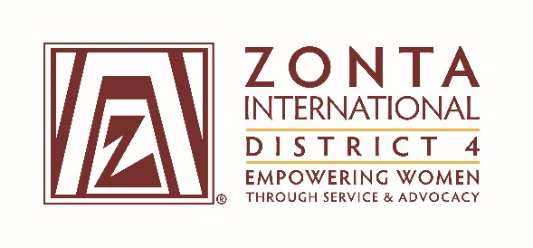

COMMITTEE CHAIR REPORT TO BOARD

DATE: May 6, 2016 COMMITTEE Communications

HIGHLIGHTS: Val continues to post regularly on the D4 Facebook page. The page has 202 likes. She posts events about our clubs, articles from Zonta International and other organizations related to women’s issues, and articles about interesting or trailblazing women. Judy has produced the Governors newsletter monthly. She also posts club events on the D4 calendar on the website and she and Sandra send communications through the club ECP’s. The Communications team has written a monthly article in the Governors Newsletter. Sandra (and her sister Nancy) visited the Niagara Falls ON club in Feb to assist with their website and social media needs. Sandra and Judy assist clubs having website problems.

CHALLENGES: Maintaining club websites is a constant challenge for many clubs. Often the person who was responsible has left or can no longer maintain it, and a new volunteer takes over. Facebook pages are much easier. Keeping up with the times is also an issue as our websites now should be mobile friendly for instance. This takes money and knowledge. Communications in some cases should be sent to all members in D4 with an email address as some club ECP’s do not do a good job or perhaps don’t know they are the ECP or what it entails.

Respectfully submitted:

Sandra on behalf of myself, Val, Catherine and Judy.

