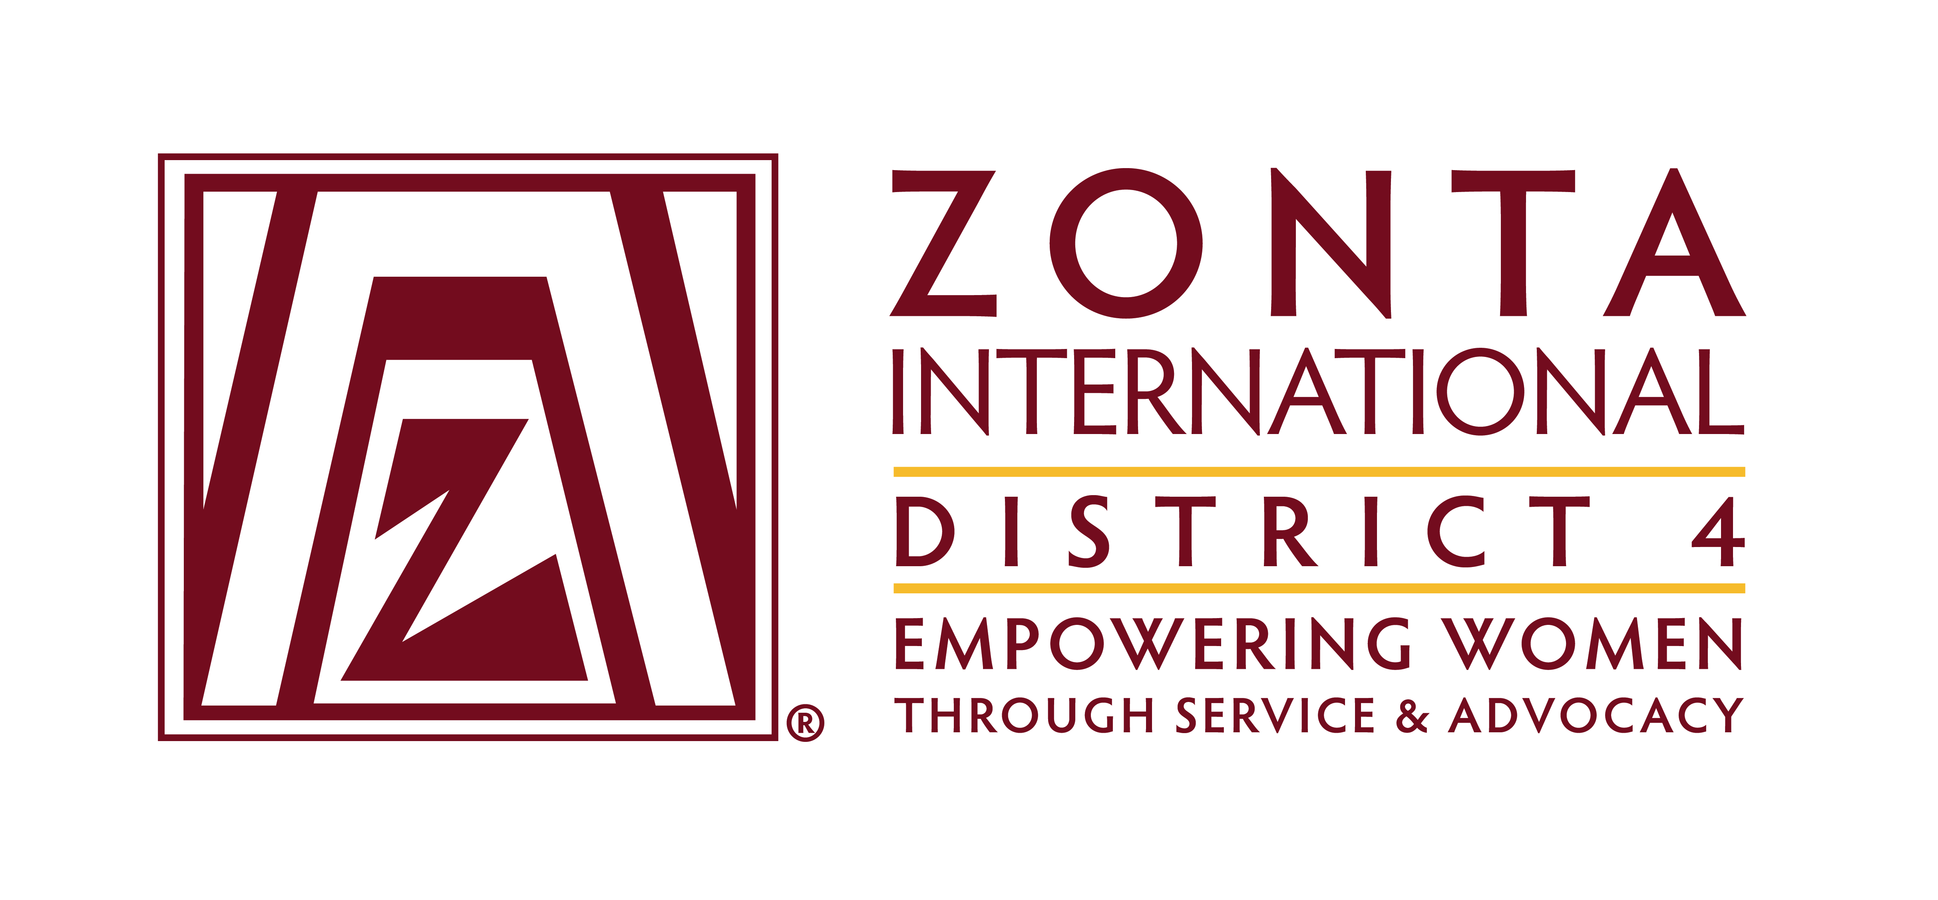

COMMITTEE CHAIR REPORT TO BOARD

DATE May 2016 COMMITTEE- ADVOCACY _

HIGHLIGHTS: Clubs across the district have been working on the district advocacy/service project. (attached is a copy of one of the posters being used by a club). Clubs have been working together on this project, and also providing help and encouragement to each other. They seem to be very excited about the project once they get started on this. At the spring workshop, one club with a poster willingly shared it with other clubs, which facilitated working together and inspired other clubs.

Connie will be doing some research on an Advocacy issue that has been brought to the attention of one of our Canadian clubs by another district, asking for our support.

Connie continues to send Canadian clubs monthly infomercials highlighting issues from various publications for information on relevant topics.

We are excited about the new Zonta International initiative regarding “adding your voice to Women’s Equality” – hopefully it will build on the great success of Zonta Says NO!

In the USA, clubs are beginning to look at Cities for CEDAW as a project to work on – in Buffalo, several clubs are beginning to deal with this together as well as with the University of Buffalo. Rochester has indicated some interest in this issue. Pittsburgh is an active partner in bringing Cities to CEDAW to the city, working with such groups as AAUW, the mayors office, and about 40 other groups. Smaller cities/towns can also work on this project, it does not have to be a large city. In Pittsburgh, Lee Fogarty has been invited to DC to participate in one of their educational evenings, and is part of the national CEDAW strategic planning group. We are very excited about this program, not just for the advocacy issues that are being addressed in many cities, and the cooperative interaction between local Zonta clubs and other local organizations, but also it has provided much visibility and knowledge of Zonta throughout the district. Nationally we have been told that Zonta has been an active member of every CEDAW initiative.

The Toronto club has been working with the White Ribbon Campaign, and gave them an award at the first area workshop

The discussion round tables at the area workshops have been very successful. Members can ask questions, highlight what they have been doing, and form working relationships. I would recommend this kind of activity at every workshop and conference. In fact, it would be a very good idea to have this at International conventions. I think it also helps advocacy chairs in districts/clubs to get to know the International and district chairs, and more readily request assistance or clarification.

The Zonta Says No campaign continues to be active in most clubs. I would recommend that clubs who have not participated regularly be partnered with nearby clubs that are active, to help them begin to participate. Sometimes it just takes encouragement and not having to reinvent the wheel to get an activity embraced.

CHALLENGES:

It continues to be difficult to connect regularly with clubs, and I would encourage new advocacy chairs to develop a process for developing ways to do this as soon as they begin. Perhaps advocacy reports could be required when ADs reports are due, written hopefully by the advocacy chairs.

We need some method to be in closer touch with our clubs so that we know what they are working on and they can learn from and support each other. Perhaps there could be a place on the District website where advocacy chairs could post actions/events in their clubs with an email contact address that they can also keep in touch with each other. Maybe this could be expanded into a Chat Room.

Clubs continue to need encouragement to use the tools provided by the district and international – it makes life easier.
There is still difficulty in making sure that clubs understand the definition of advocacy as opposed to service so we need to continue to work on this within the district.

Respectfully submitted:

Connie Deckert and Lee Fogarty name)

