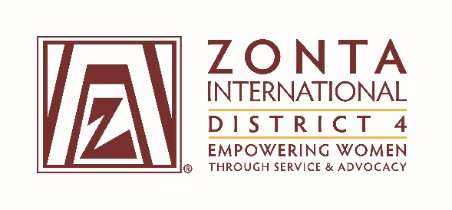

COMMITTEE CHAIR REPORT TO BOARD

DATE: April 25, 2016 COMMITTEE: Membership

HIGHLIGHTS:

- Presenting the new Membership Campaign Voices against Gender Equality was a highlight at Area Workshops.
- Inductions at the end of the year for a number of clubs.
- Zing funding being requested this year for growth. (Cambridge)

CHALLENGES:

- Some confusion in the Voices Campaign. Some participants found it hard to distinguish between Membership and Advocacy.
- Encouraging newer members to step up to leadership in the clubs has been a struggle. I am not sure if this is a flaw in our club recruitment in setting expectations.
- I am dissappointed that we have not chartered a new club this biennium.

Respectfully submitted:
Lori Robinson
Lt.. Governor

