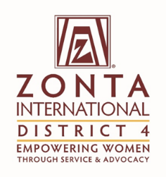 | Title: | SOM
 | From: | Joanne Raymond
 | Date: | November 4, 2016

To: | The Zonta International District 4 Board

Purpose of the report (please mark as many as applicable):

* | For Information |  | For Discussion |  | For decision

Facts (Information)
This section can contain activities since the last report, factual information to be brought to the Board regarding issues from Clubs or from Committees, other matters.

If the report is a follow-up to a previous report, refer to the date, title, and decisions of the previous report.

Initiative | Specific Actions | Highlights/Challenges
To begin process of collecting information regarding starting a club in Barrie | Meeting has been arranged with Barbara Fer a for November 15.

Motion
This section includes the motion (s) if any for the Board to discuss and vote on.
Rationale
This section includes the rationale of the motion

Evaluation (Discussion)
As board member, and voice of Clubs and committees, express the pros and cons of the motion (s) presented.

Please be clear about:

- The challenge the proposal addresses
- Stakeholders who will benefit and how
- Added value to Zonta
Supporting Documentation
List any attachments to be considered as part of this report.

