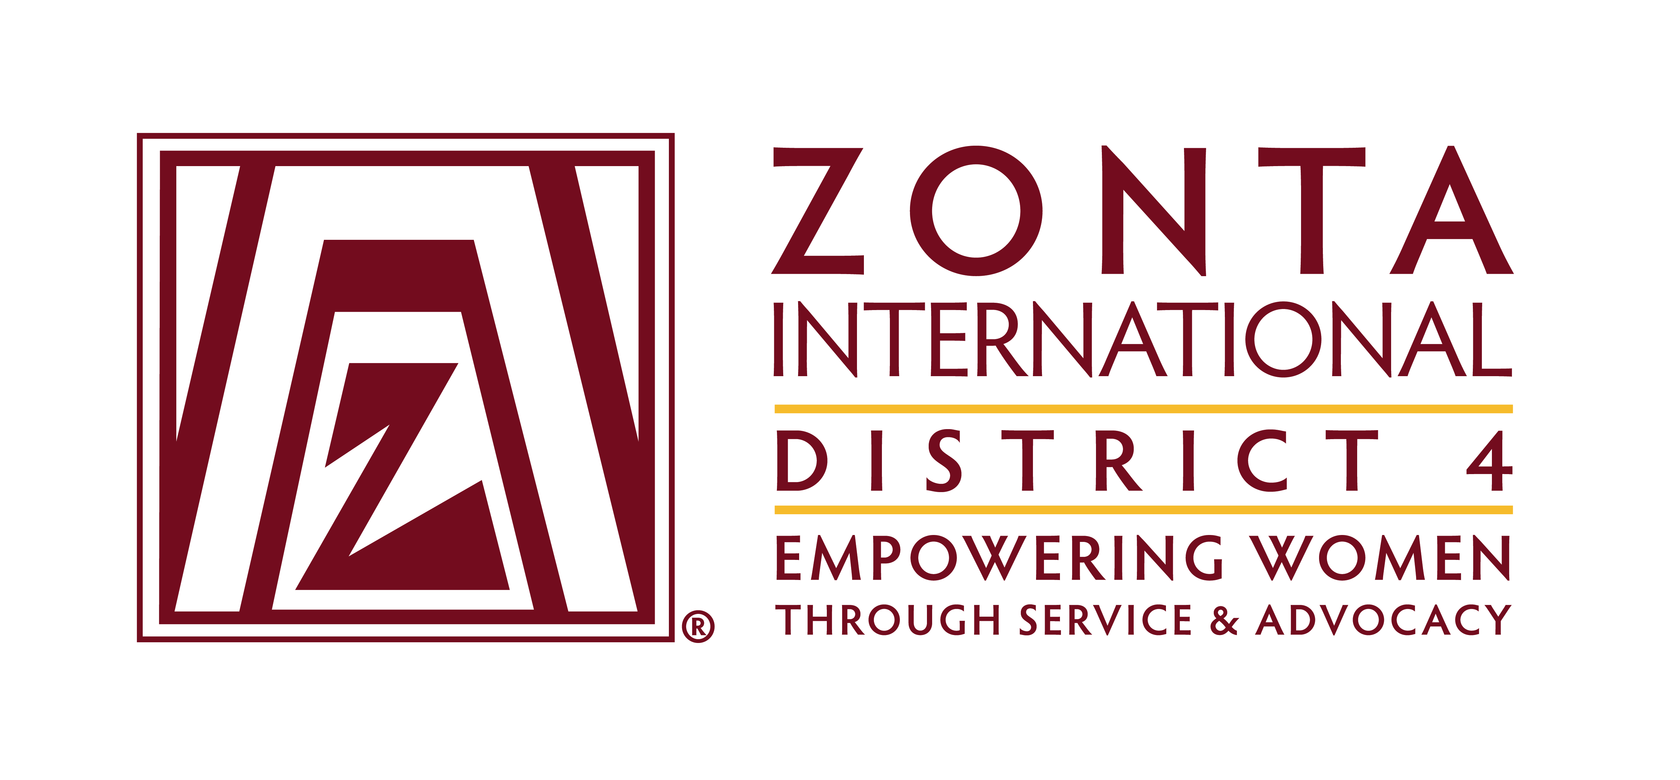
COMMITTEE CHAIR REPORT TO BOARD
DATE: January 14, 2016
COMMITTEE: Service
Highlights:

Birthing Kits
On November 26, 2015 the clubs in Ontario delivered about 4000 kits to World Vision Canada that are destined for the Democratic Republic of Congo. The club representatives had an excellent meeting with the World Vision staff at their headquarters.
Several US clubs are collecting supplies to assemble kits this spring.
The backlog of kits from last year has been cleared.

District 4 Club Service Recognition Awards
We received 8 nominations. The applications are being evaluated by a committee of judges and three will be chosen for submission to ZI.

Challenges:
Birthing Kits
We continue to work to find partner organizations to ship and distribute birthing kits. There have been some successes on both sides of the border but it would be excellent to be able to support clubs in both Canada and the US with contacts for partnering organizations. We are building a database of birthing kit availability for the clubs, as well as resources for the contents.

Advocacy project support
We are continuing to work with the clubs to support them in implementing their advocacy projects. The Oakville, Olean, Jamestown and Niagara Falls clubs are all moving forward. There are probably others we have not been in contact with.

District 4 Club Service Recognition Awards
Clubs are working on many wonderful service projects. We would have liked to receive more nominations sharing their projects. We need to encourage more participation in the future.

Respectfully submitted:
Judy Powers Holly Anderson

